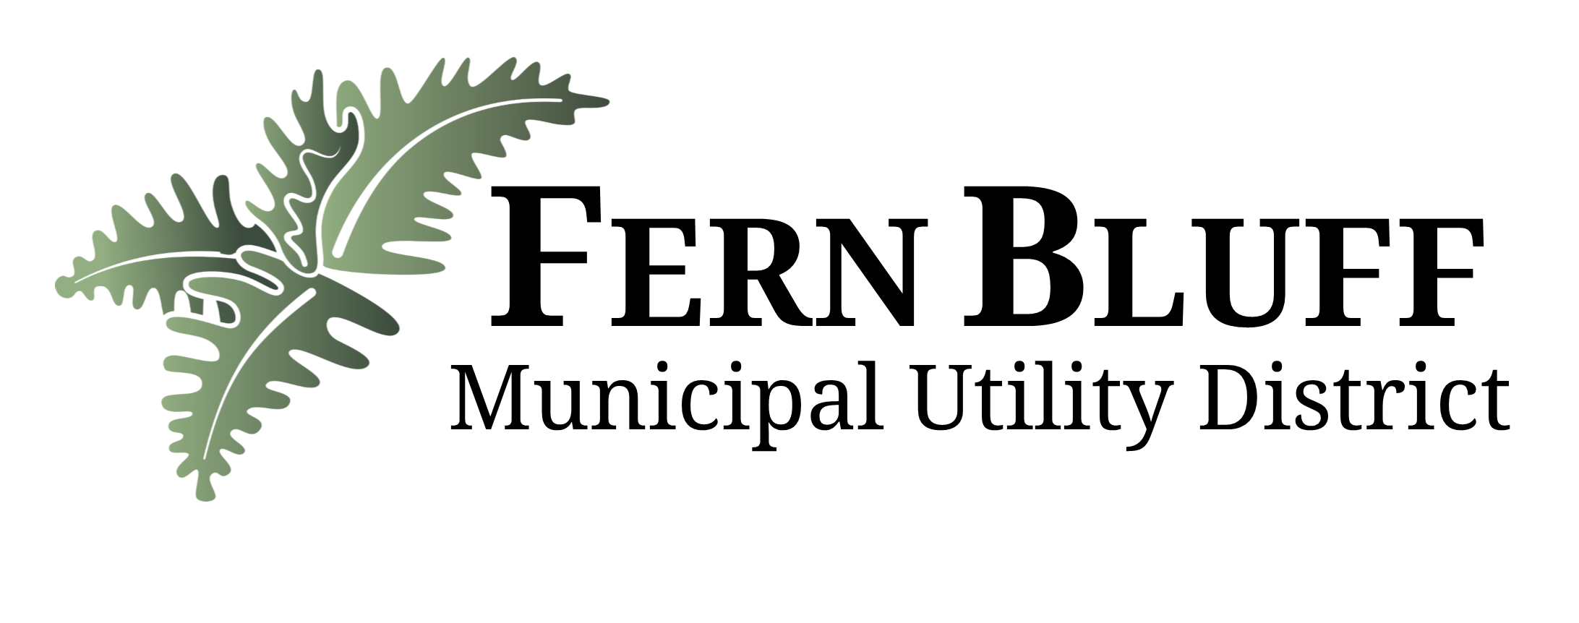
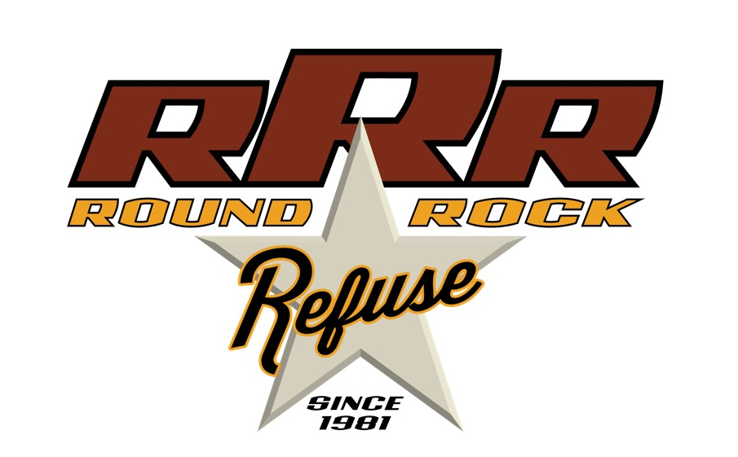

Fern Bluff MUD Spring Cleanup
On Saturday July 25, 2020. Fern Bluff MUD will have its SPRING CLEAN UP. Round Rock Refuse, the MUD’s contractor for solid waste removal will collect trash and brush placed at the curb. Items can be placed on the curb NO LATER THAN JULY 25TH, at 7 a.m. Items placed after 7 a.m. will be the resident’s responsibility to dispose. When placing items, please do not block the sidewalk. Items may be placed in the street. If you encounter any pickup issues, please contact Central Texas Refuse at 512-255-4980.

Items that can be discarded include:
- Non-Freon appliances (washer, dryer, stove etc.) (Please provide 2 feet of side clearance for appliances)
- Carpeting (must be less than 4’ long)
- Furniture
- Scrap metal (must be less than 4’ long)
- Treated wood (fence materials)
- Mattresses
- Tree limbs *must be bundles with rope or twine*
  - Limbs must not exceed 4” in diameter
  - Limbs must not exceed 4’ in length
  - No palm tree or cacti limbs will be accepted
Items that cannot be discarded include:
- Freon appliances (refrigerators, freezers, air conditioner units)
- Televisions and computers (contact local appliance recyclers)
- Automotive products/fluids (accepted at Recycling Center)
- Paint (accepted at Recycling Center)
- Hazardous chemicals (accepted at Recycling Center)
- Demolition/construction debris or metal fencing
- Tires
- Batteries, ammunition or explosives
- Concrete or rocks
- Railroad tie lumber,
- Pianos, hot tubs, motorcycles or items larger than a normal size appliance

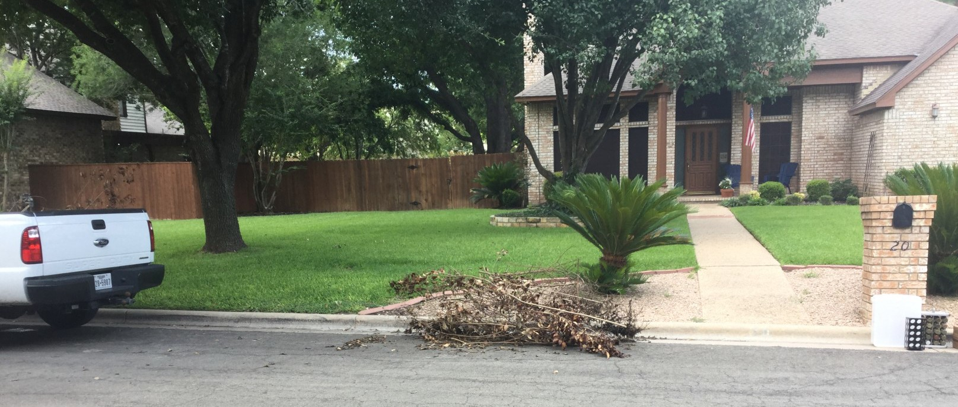



When discarding brush and other items please make two separate piles, one for brush and one for everything else. No trash or treated wood in the brush pile. Brush piles with bulk trash mixed in will be skipped and will be the resident’s responsibility to remove.
Brush piles must have 5 feet of clearance on both sides and free from obstructions 15 feet tall.

Do not place brush piles within 5 feet of mail boxes, poles, trees, parked cars, and the bulk trash pile. The brush pile may not exceed 4 feet in length and weigh less than 40 pounds. Tree branches cannot exceed 4” in diameter. The brush must be bundled with rope or twine. Tree stumps are not accepted failure to follow the guidelines will result in the resident being responsible for the removal.
- Freon appliances such as refrigerators, freezers, air conditioner units or other appliances that at one time contained Freon, cannot be accepted. The following companies offer Freon appliance recycling services:
  - Appliance Collector – 512-650-0528

